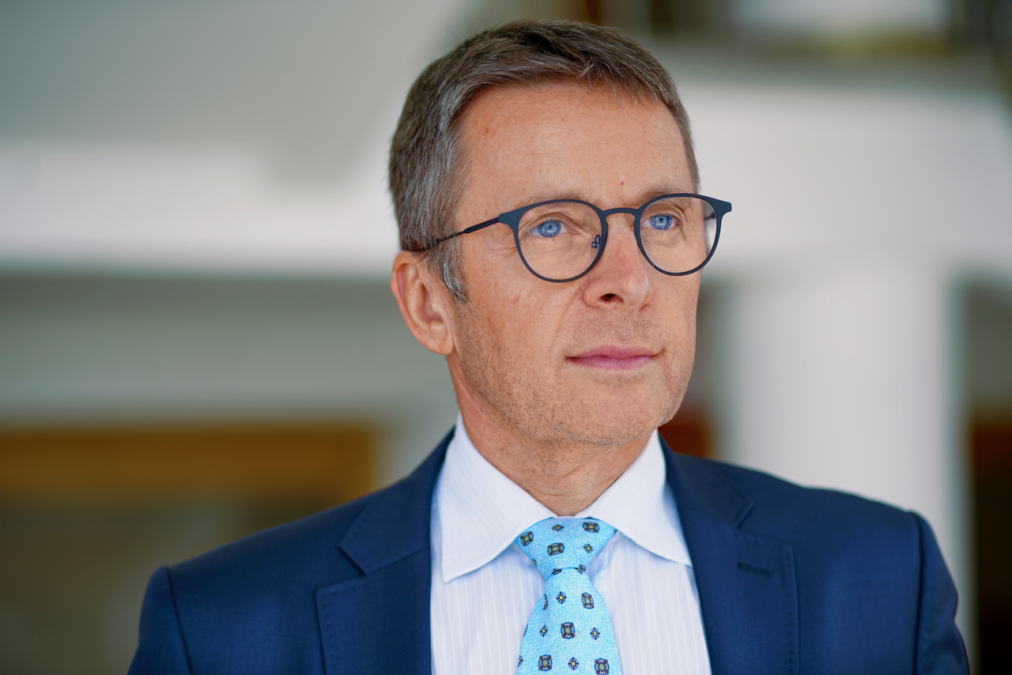

Ivan Mikloš
Mr. Miklos would like to propose the following title for his keynote:

Why is EU integration a key precondition for the success of post-communist countries, and what else is important in today's turbulent geopolitical environment?

Would this title be suitable for you?

Please find attached his photo and a short bio.
Affiliation: Former Deputy Prime Minister and Minister of Finance of the Slovak Republic

Ivan Mikloš is former Deputy Prime Minister and Minister of Finance of the Slovak Republic (2002-2006, 2010-2012), Deputy Prime Minister for Economy (1998-2002), and Minister of Privatization (1991-1992). He has co-founded and led the economic think tank MESA10 (1992-1998). Between 2006-2010 and 2012-2016, he was a Member of Parliament. In 2014, he was reappointed as the President of MESA10. During 2015-2016 he served as a Chief Advisor to the Minister of Finance of Ukraine and as an Advisor to the Minister of Economic Development and Trade of Ukraine. Since April 2016 until August 2019, he served as a Chief Economic Advisor to the Prime Minister of Ukraine. After the change of the government, from November 2019 until March 2020, he was in position of an Economic Advisor to the Prime Minister of Ukraine. In years 2016-2020 he chaired the Strategic Advisory Group for Support of Ukrainian Reforms (SAGSUR). He is also Co-Founder of the Ukrainian economic think tank Centre for Economic Strategy. He served as an Advisor to the Prime Minister of Moldova (2021-2022). From March 2022 until June 2024, he was an Advisor to the President of the Slovak Republic in the field of economic policy.

Ivan Mikloš was one of the leading figures of economic transformation in the Slovak Republic. He significantly contributed to the entry of the Slovak Republic into the OECD and instigated an extensive and effective tax reform. He led the government agenda on economic restructuring and fiscal consolidation. The second Dzurinda´s government (2002-2006) gained a very reformist reputation thanks to severe austerity measures and a comprehensive program of structural reforms (tax, social sector, pension, healthcare, public finance, labour market) backed by Ivan Mikloš. Thanks to these reforms, Slovakia was able to join the Eurozone in 2009. In 2004, he was awarded “Best Minister of Finance of the Year” by Euromoney, and “Top Business Reformer” by the World Bank´s Doing Business report.

Ivan Mikloš is the author of “Book of Reforms” (2005), “Rewriting the Rule” (2001) and dozens of studies and articles in the expert and popular press. He is also the author of the chapter about Slovak reforms in the book “The Great Rebirth: Lessons from the Victory of Capitalism over Communism” (2014). In 2019, under his leadership SAGSUR published the book about Ukrainian reform process “Reforms in Ukraine after Revolution of Dignity: What was done, why not more and what to do next” (2019), to which he contributed the chapter “Political Economy of Reforms: Political system, governance and corruption”.

